1. First output when you run a program.

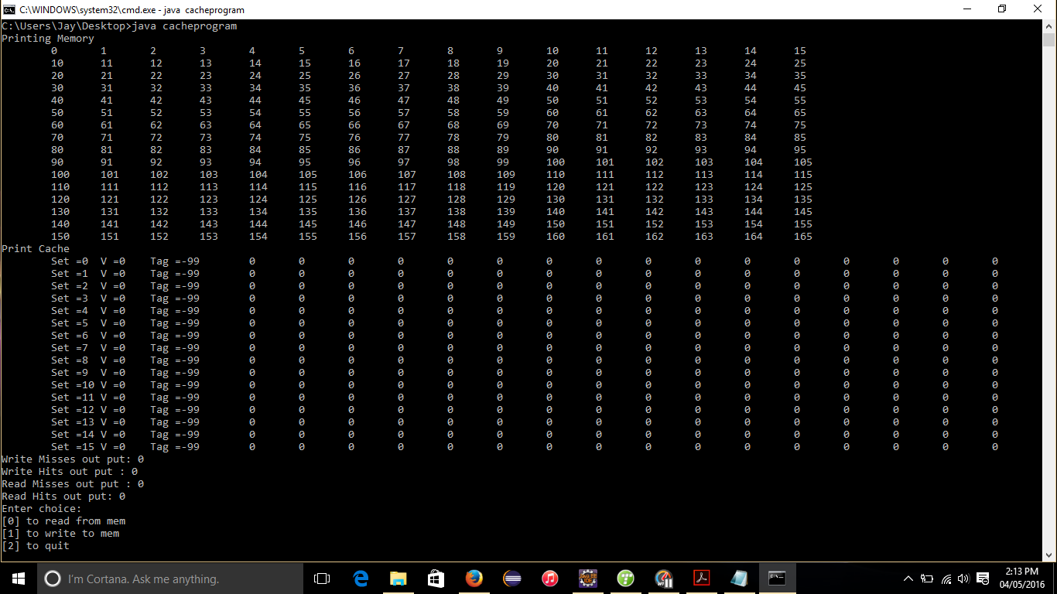

1. Reading from the memory. (Read memory block 2: cache performance read miss =1)

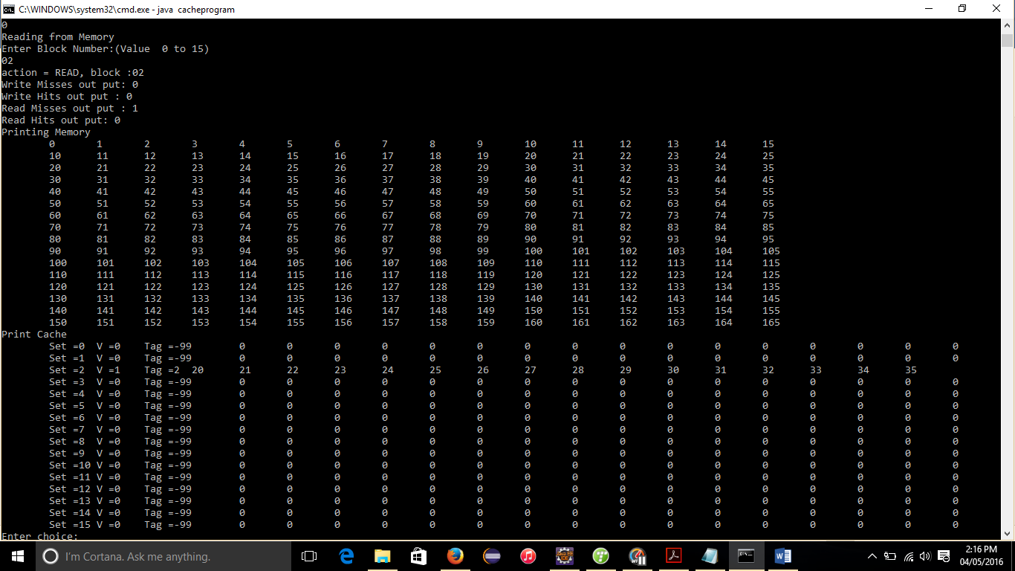

1. Reading from memory (Read memory block: 3 cache performance read miss: 2)

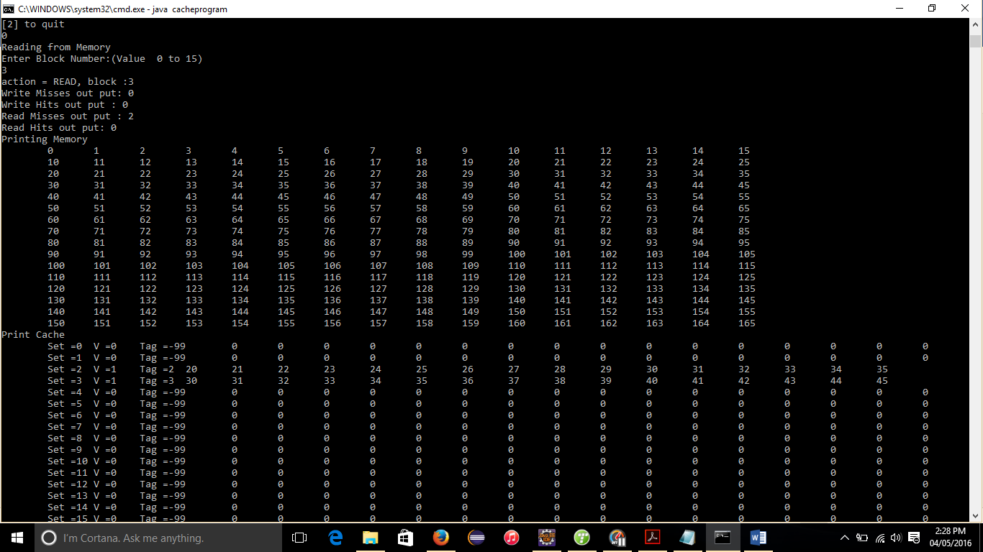

1. Reading from memory (Read memory block: 3 cache performance read miss: 3 Read hit: 1)

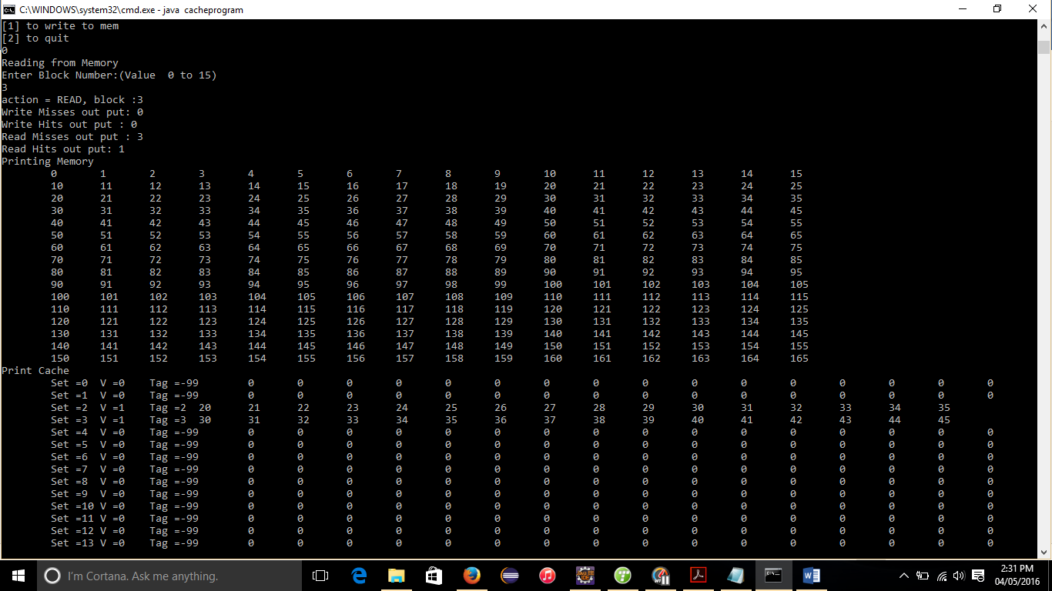

1. Writing to memory (write memory block : 15 offset value : 15 value: 8888 write miss set to: 1)

